**Jenkins**

Jenkins Tutorial is designed for both beginners and professionals. Our Tutorial provides all the basic and advanced concepts of Jenkins, such as Jenkins installation, Jenkins Configuration, Jenkins Pipeline, etc. Jenkins is an open source automation tool written in Java programming language that allows continuous integration. Jenkins builds and tests our software projects, which continuously making it easier for developers to integrate changes to the project, and making it easier for users to obtain a fresh build.

### **The below are some common uses of the Jenkins:**

1. Building snapshot and release artifacts for your application.  
2. Deployment of the released artifact with custom scripts.  
3. Continuous integration pipeline support for establishing software development life cycle workflow for your application.  
4. Support for scheduled builds & automation test execution.

### **Advantages of Jenkins:**

1. It is an open-source tool with great community support.
2. It is easy to install.
3. It has 1000+ plugins to ease your work. If a plugin does not exist, you can code it and share it with the community.
4. It is free of cost.
5. It is built with Java and hence, it is portable to all the major platforms.

**Features of Jenkins:**

1. **Adoption:** Jenkins is widespread, with more than 147,000 active installations and over 1 million users around the world.
2. **Plugins:** Jenkins is interconnected with well over 1,000 plugins that allow it to integrate with most of the development, testing and deployment tools.

## 

## Continuous Integration with Jenkins:

Continuous Integration is a development practice in which the developers are required to commit changes to the source code in a shared repository several times a day or more frequently. Every commit made in the repository is then built. This allows the teams to detect the problems early. Apart from this, depending on the Continuous Integration tool, there are several other functions like deploying the build application on the test server, providing the concerned teams with the build and test results, etc.

## Automated CI/CD with Jenkins. CI CD Pipeline implementation or the ...

The above diagram is depicting the following functions:

* First, a developer commits the code to the source code repository. Meanwhile, the Jenkins server checks the repository at regular intervals for changes.
* Soon after a commit occurs, the Jenkins server detects the changes that have occurred in the source code repository. Jenkins will pull those changes and will start preparing a new build.
* If the build fails, then the concerned team will be notified.
* If built is successful, then Jenkins deploys the built in the test server.
* After testing, Jenkins generates feedback and then notifies the developers about the build and test results.
* It will continue to check the source code repository for changes made in the source code and the whole process keeps on repeating.

**Jenkins Email Notification:**

Jenkins email notifications is the way to notify based on event occurred or some action happened. Jenkins email notifications is kind of message that is automatically sent to you and update that, there has been activity on one of your social media accounts like Google, slack. As email is the primary means of notification among other social media for Jenkins email notifications. Jenkins provided a plugin to extend functionality of e-mail notifications. It’s basically informing users about some event or status or any information’s that needs to be update to their concern users.

* **Triggers:** This is a defined condition which causes an e-mail notification to be sent.
* **Content:** Basically, defined content for email subject and body.
* **Recipients:** We can mention the concerned user who is supposed to receive an e-mail when any event occurs.

### **Configure Gmail SMTP Server in Jenkins:**

## Jenkins email notifications is the way to notify based on event occurred or some action happened. Jenkins email notifications is kind of message that is automatically sent to you and update that, there has been activity on one of your social media accounts like Google, slack. As email is the primary means of notification among other social media for Jenkins email notifications. Jenkins provided a plugin to extends functionality of e-mail notifications. It’s basically informing user about some event or status or any information’s that need to be update to their concern users.

There are basically two ways to configure email notifications in Jenkins.

1. **Using Email Extension Plugin** – This [plugin](https://plugins.jenkins.io/) lets you configure every aspect of email notifications. You can customize things such as when to send the email, who receives it, and what the email says.
2. **Using Default Email Notifier** – This comes with Jenkins by default. It has a default message consisting of a build number and status.

**Steps:**

Step 1: Download Jenkins war file from their official website and save it in your system

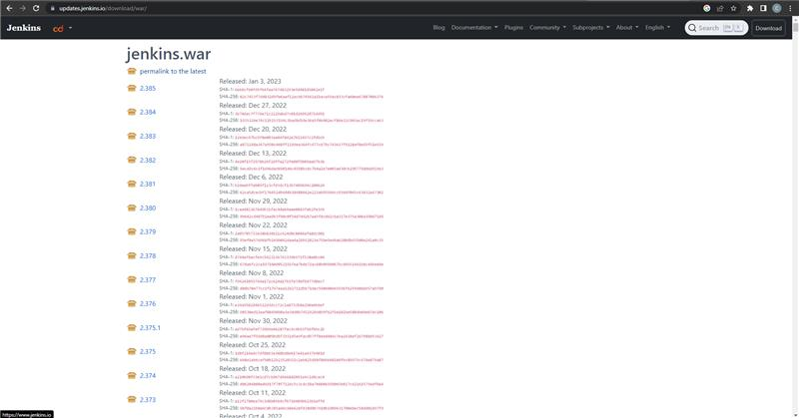

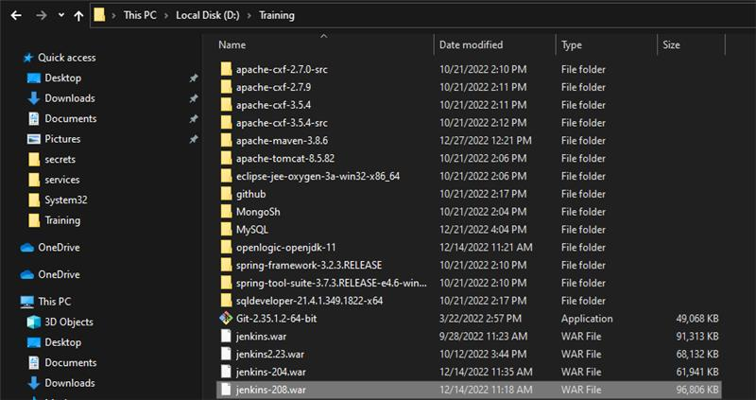

Step 2 : Run the war file in CMD using the command java -jar <FILENAME>

Step 3: Jenkins should be up and running post that

Step 4: To access Jenkins, open any web browser and browse to <http://localhost:8080/> ( the default port address for Jenkins is 8080 ). This will give you access to the entire dashboard of Jenkins where we can access all of its entirety.

**Screenshots of the mails received on build fail/success:**

